SYSTEM ARCHITECTURE DESCRIPTION
The ResearchMate AI: Intelligent Research Paper Analysis and Literature Review Assistant follows a modular architecture that combines document processing, information retrieval, Natural Language Processing (NLP), Large Language Models (LLMs), and Retrieval-Augmented Generation (RAG). The architecture is designed to accept research papers from users, process and store their information, retrieve relevant content based on user queries, and generate meaningful responses.
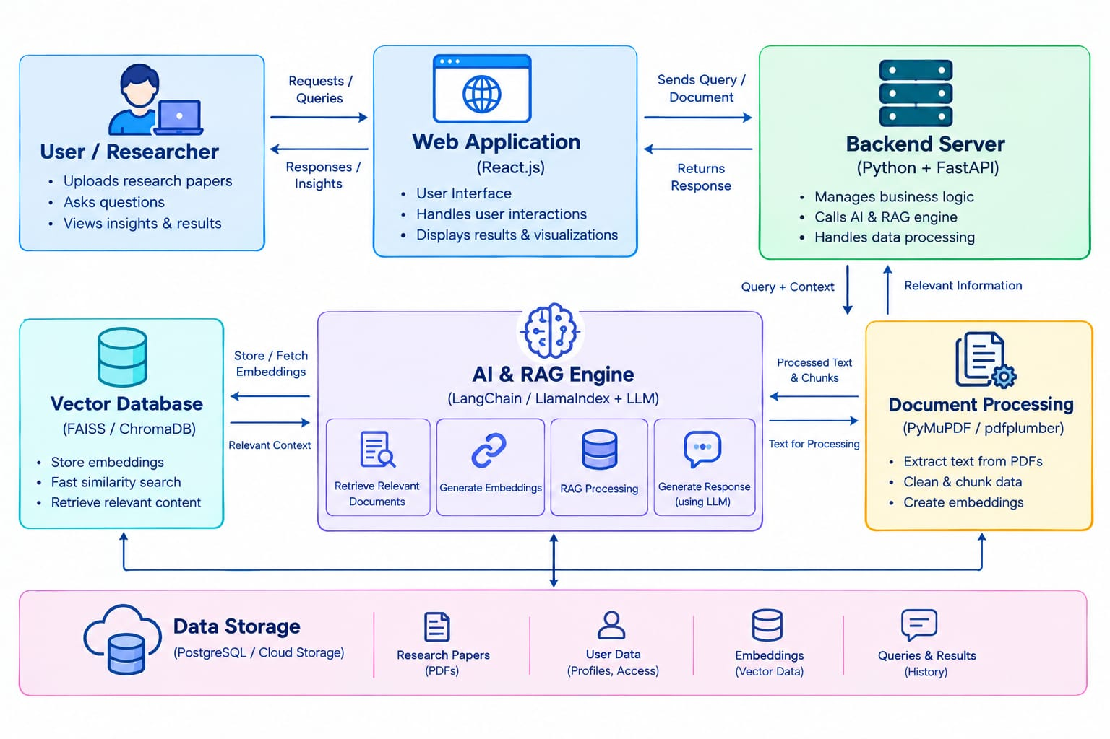
- User / Researcher: uploads research papers, asks questions and views insights and results.
- Web Application (React.js): provides the user interface, handles user interactions and displays results and visualizations.
- Backend Server (Python and FastAPI): manages business logic, calls the AI and RAG engine and handles data processing.
- Document Processing (PyMuPDF / pdfplumber): extracts text from PDFs, cleans and chunks the data and prepares it for embedding.
- AI & RAG Engine (LangChain / LlamaIndex with an LLM): retrieves relevant documents, generates embeddings and generates the response.
- Vector Database (FAISS / ChromaDB): stores embeddings, supports fast similarity search and returns relevant context.
- Data Storage (PostgreSQL / cloud storage): keeps research papers, user data, embeddings, and queries and results.

MODULES DESCRIPTION
The ResearchMate AI: Intelligent Research Paper Analysis and Literature Review Assistant is divided into several modules, where each module performs a specific function in the research analysis process.
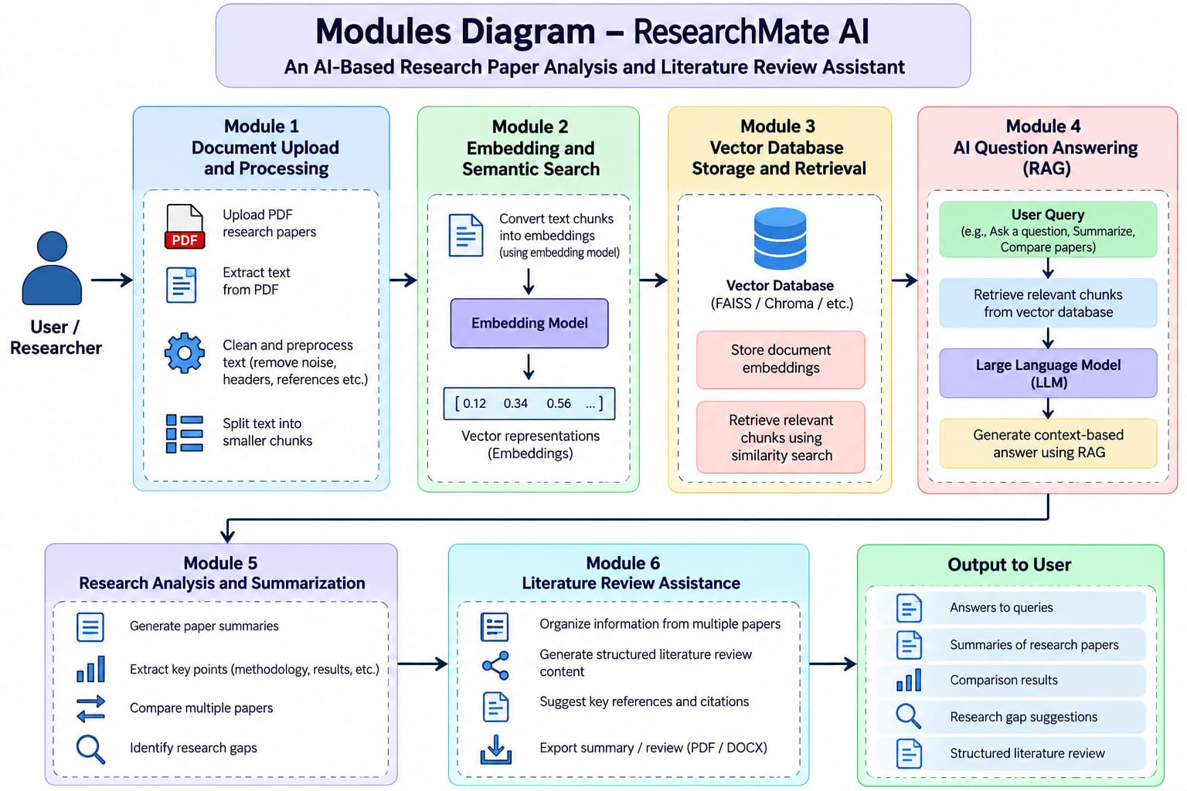
: Module-level flow of ResearchMate AI
Table 10.1: Module description
No. | Module | Description | Main output
1 | User Management | Registration, login, sessions and per-user paper libraries. | Authenticated sessions; private library
2 | Document Processing | PDF upload, text extraction, cleaning, section detection and chunking. | Clean chunks with page and section data
3 | Semantic Search and Vector Database | Embedding of chunks and queries; similarity search over the vector index. | Top-k relevant passages
4 | AI Analysis and RAG | Prompt construction, grounded generation, citation handling and verification. | Answers with citations
5 | Research Analysis | Summaries, cross-paper comparison, research-gap identification and concept explanation. | Summaries, comparison matrix, gap list
6 | Literature Review | Organizing papers by theme and drafting a structured literature survey. | Survey draft, study notes
7 | Visualization and Content Generation | Display of results and generation of notes, slide content and downloadable files. | Tables, charts, slide outline, files

UML DIAGRAMS
Use Case Diagram :
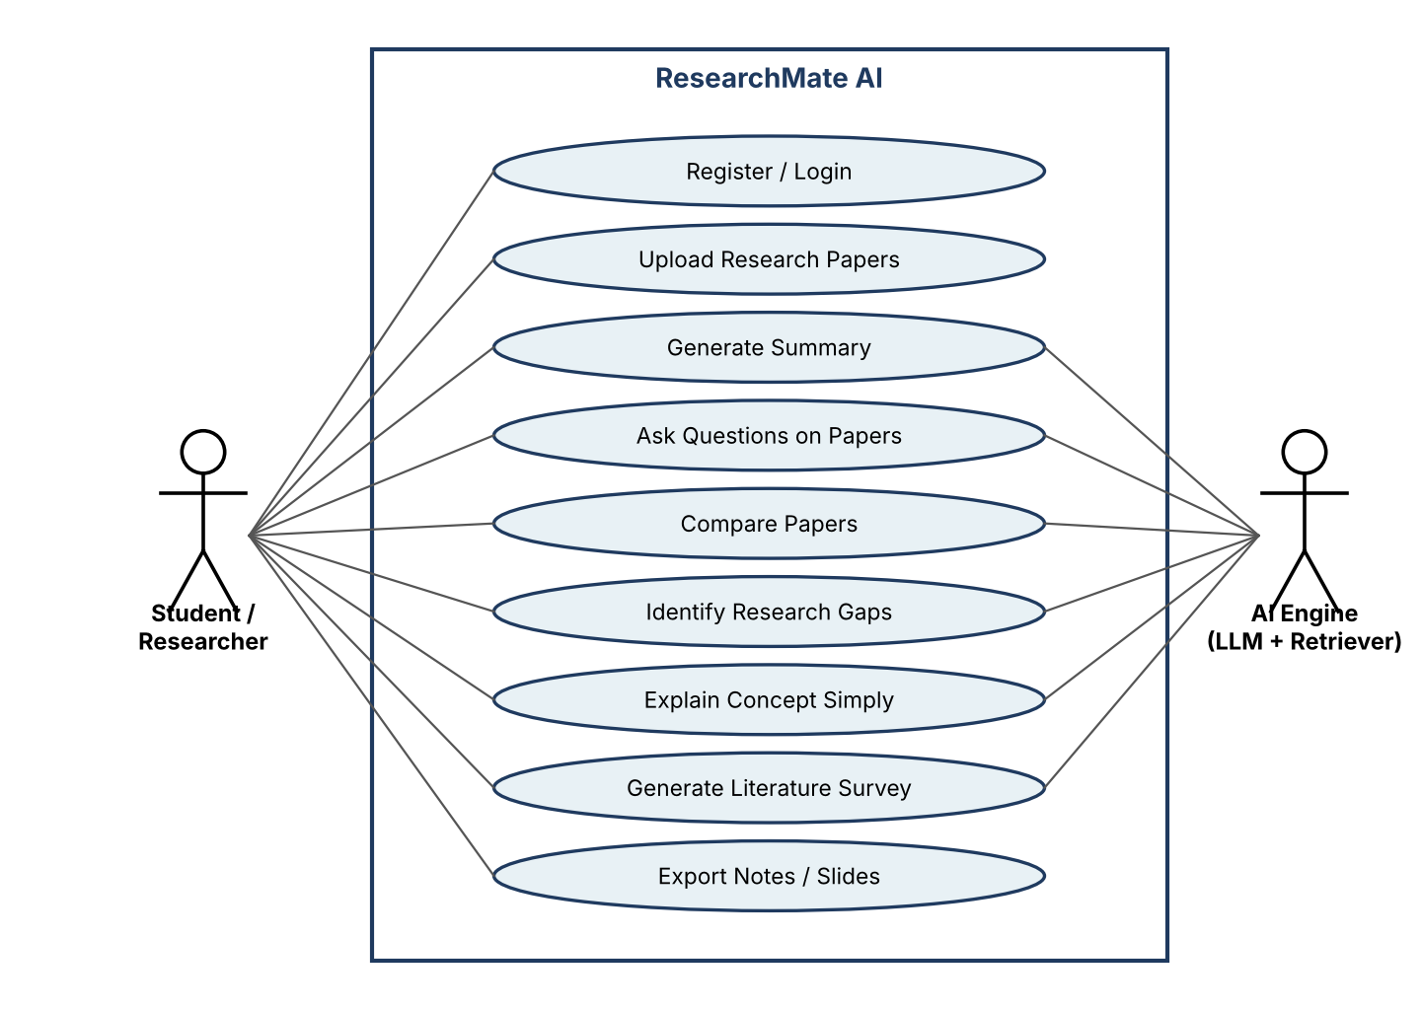
Class Diagram :
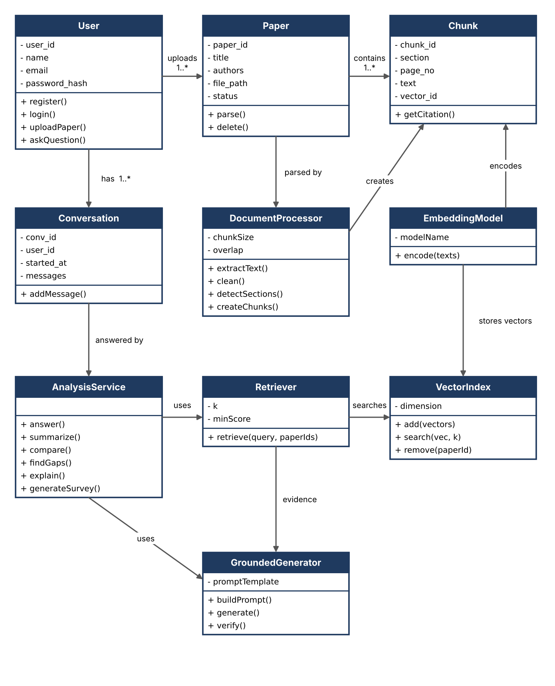
Sequence Diagram :
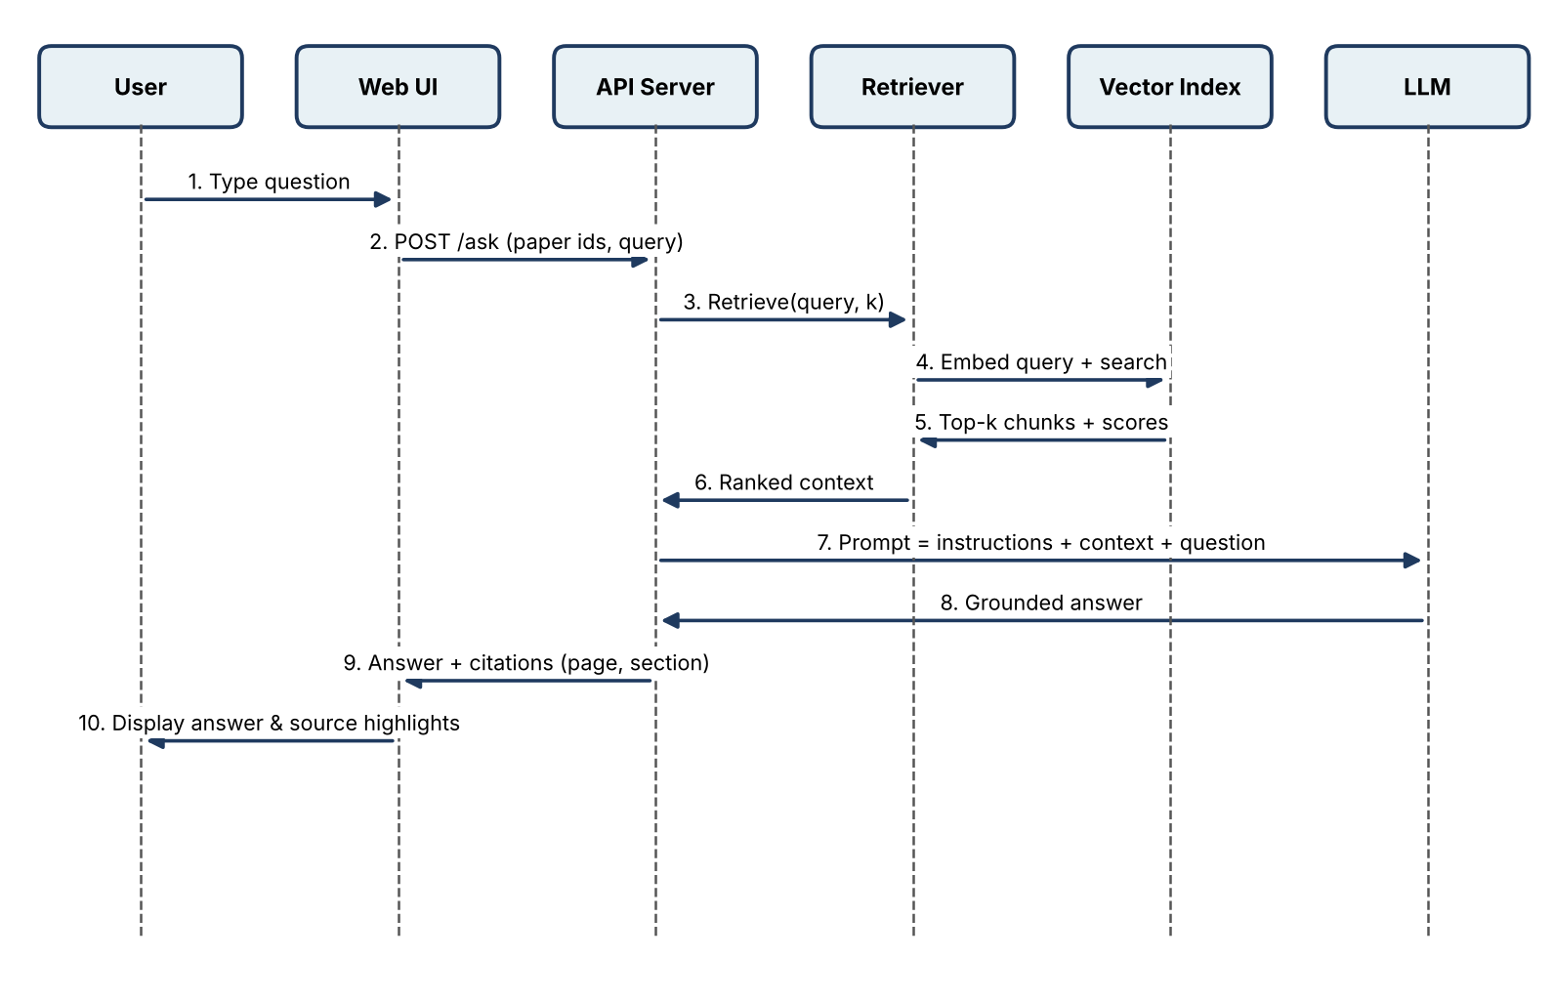
Activity Diagram:
